you'll have no doubt seen we're using various different data types Now, it's a programmer's responsibility to make sure the data types you use are compatible with each other when you use them for calculations or moving data to and from those objects throughout your program.

You do not want to be performing any calculations on variables and numbers that do not match.

For example, a variable defined as an integer cannot be multiplied by a character. The two data types are incompatible, and as a result, the system would generate syntax error and runtime error if you try to execute the program.

Now, SAP have built in some automatic data from many of the standard data types that are available within ABAP. There are scenarios where the inbuilt ABAP conversion rules are not appropriate and it is important you become familiar with the inbuilt conversion rules, and know when to manipulate the data prior to rules that currently exist.

conversion rules are predefined logic that determine how the contents of the source field can be entered into a target field.

If you have an integer field containing the value of one, and try to insert that value into a character string, the built in conversion rules in conversion rules will determine exactly how this should be done without throwing any syntax errors or runtime errors.

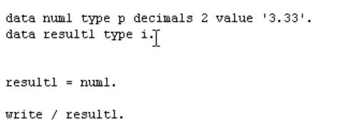

 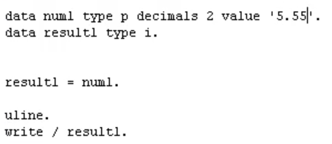

So, you can see, automatic conversion rules are being applied. As you work with different data types within your program, many different conversion rules will be applied automatically.